CLUCK & QUACK
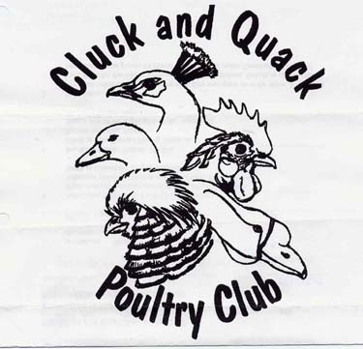
POULTRY CLUB
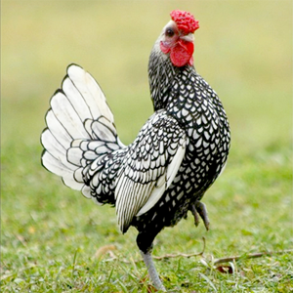
AUCTION
PUREBRED AND HERITAGE BREEDS
POULTRY and
SMALL ANIMALS
SPRINGFIELD CURLING CLUB
DUGALD MB @ HWY 15 & 206
SATURDAY April 18, 2020
Doors open to public 10:00 AM
AUCTION IS 12 Noon – 4:00PM
For information Contact
DANICA MUTCHER BOX 43 GROUP 17 RR 2 DUGALD, MB. R0E 0K0
PH 204-444-5259 CELL 204-770-3854 E-mail: danimonica@hotmail.com
THERE IS A LOT LIMIT
DO NOT GET LEFT OUT
REGISTER EARLY

