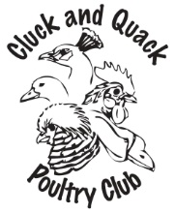
Cluck and Quack Poultry Club
2019 MEMBERSHIP
New/Renewal
Individual or family
Send form with $15.00 to :
Kylie Wasiuta
Box 1, Grp 540, RR# 5
Winnipeg, MB
R2C 2Z2
* Make cheque payable to 'Cluck and Quack Poultry Club'
By becoming a member,
I agree not to use the Membership Directory for any reason
other than personal contact with other members of the Club.
NAME:_________________________________________________________
ADDRESS:________________________________________________________
________________________________________________________
POSTAL CODE:__________________PHONE NUMBER: __________________
EMAIL ADDRESS:__________________________________________________
POULTRY AND OTHER CRITTERS OWNED:
BANTAMS________________________________________________________
STANDARDS______________________________________________________
Pheasants___________________________________________________________
Ducks______________________________________________________________
Geese_______________________________________________________________

Other-feathered _______________________________________________________

Non-feathered-________________________________________________________

At-home Business______________________________________________________

