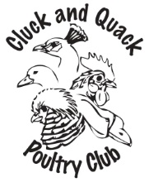
Cluck and Quack Poultry Club
2021 MEMBERSHIP
New/Renewal $15.00 for Individual or family

If you have the ability to e-transfer funds ($15.00) send them to "Kylie Wasiuta" barrelracer_cwgrl@hotmail.com PLEASE MAKE THE TRANSFER PASSWORD: MEMBERSHIP
and e-mail the completed form to bhartmann@xplornet.com

OTHERWISE
Send form with $15.00 to:
A W (Bill) Hartmann
65063 Eastdale Rd.
Anola, MB
R5L 0B2
* Make cheque payable to 'Cluck and Quack Poultry Club'
Upon becoming a member, I agree not to use the Membership Directory for any reason other than personal contact with other members of the Club.
NAME:

ADDRESS:

POSTAL CODE: PHONE NUMBER:
EMAIL ADDRESS:
POULTRY AND OTHER CRITTERS OWNED:
BANTAMS:
STANDARDS:
Pheasants:
Ducks:
Geese:

Other-feathered:

Non-feathered:

At-home Business:

